**Procedures to set up *BULK SEPERATOR* on Touch-Screen (HG2G)**

1. On the main screen, press **MENU**

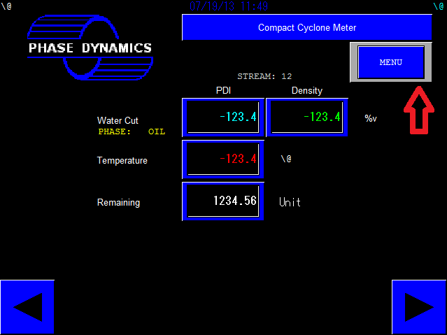

1. In OPERATOR INTERFACE TERMINAL, press the left blue box 5 times and immediately follow by press up right blue box once to enter the FACTORY MODE

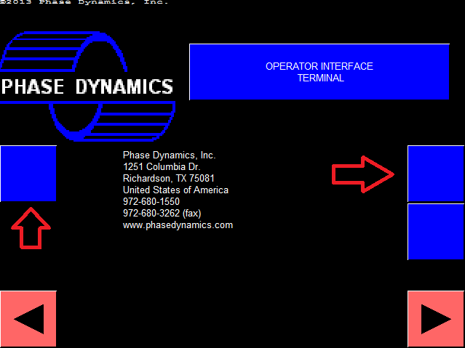

1. If LOCK shows red, enter PASSWORD “1343”. The LOCK should now show green

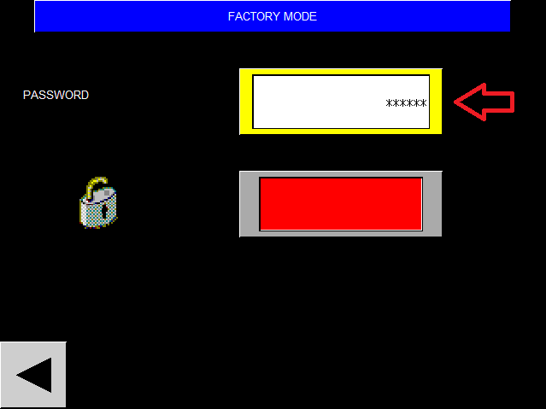

1. Go back to the OPERATOR INTERFACE TERMINAL and press the down right blue box once

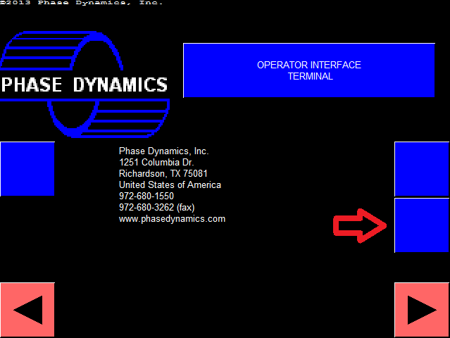

*For Bulk Separator* ***with*** *Micro Motion Coriolis:*

Press BULK SEPARATOR and BULK WATER CUT DISPLAY switches to turn both on

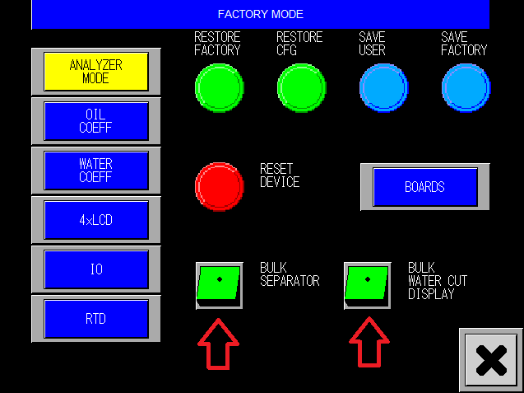

*For Bulk Separator* ***without*** *Micro Motion Coriolis:*

Press BULK SEPARATOR switch only

